**EE Senior Design**

**Project Statement of Work**

**<Project Name>**

**Texas State University**

**Ingram School of Engineering**

**<Name Project Manager Here>**

**<List Remaining Names of Team Members Alphabetically Here>**

**SPONSOR Company Name**

**Street Address**

**City, State Zip Code**

**Date**



Remove this box and put an approved Sponsor logo in this space but ONLY if the Sponsor approves doing so. If not, remove this box and center the TxState logo.

***Delete the contents of this page before submitting.***

The contribution of each team member must be clearly identified in this document. You may perform this identification in any manner **as long as it is clearly shown**.

**EXAMPLES**

**1.** *The Executive Summary was written by John Doe.* <Executive Summary then follows this statement>

**2.** Identified by paragraph, table, etc.

*John Doe:*

The Inverting Flurbitron is an extremely proliferous device in the magnetohydrodynamics area. While Flurbitrons have been available since the 1950's, it was only recently that Kygo & Selena shocked the world with the announcement of a reliable inverting Flurbitron. The applications are obvious.

*Jane Doe:*

An alternative to solving the system problem with an Inverting Flurbitron is to use a Turbo Encabulator. The original machine had a base plate of prefabulated aluminite, surmounted by a malleable logarithmic casing in such a way that the two main spurving bearings were in a direct line with the pentametric fan. The latter consisted simply of six hydrocoptic marzlevanes, so fitted to the ambifacient lunar waneshaft that side fumbling was effectively prevented. The main winding was of the normal lotus-o-delta type placed in panendermic semi-bovoid slots in the stator, every seventh conductor being connected by a nonreversible tremie pipe to the differential girdlespring on the "up" end of the grammeters.

*Joe Doe:*

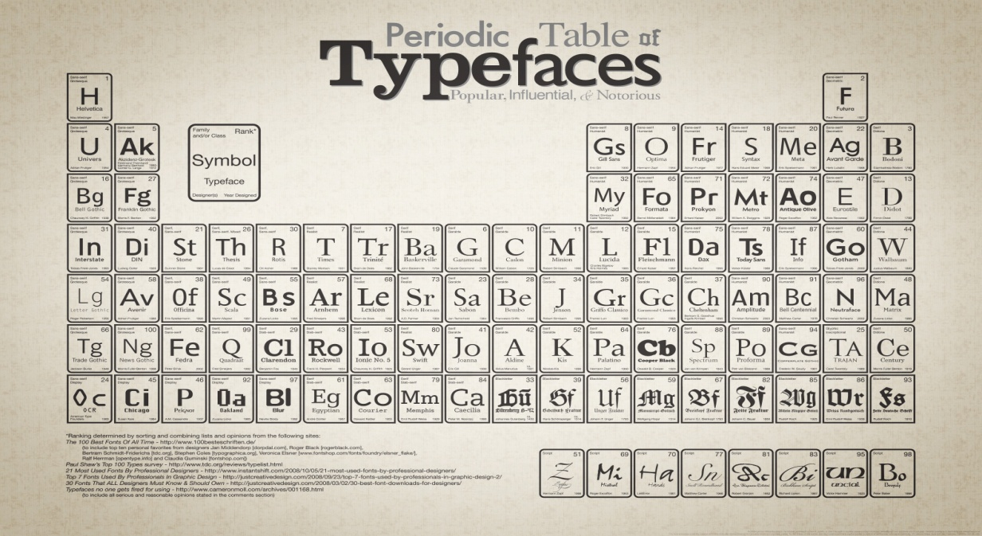

*The revision history block documents major revisions to the document as the project progresses. Spelling mistakes and other minor adjustments do not need to be summarized in this block. Add versions to the block as necessary (there may be more than 3).*

*You need to decide what makes sense in terms of revisions while the document is being written. As an example:*

*Version 0.1 – includes template information, adds Section Owners*

*Version 0.5 – first team review, template information removed*

*Version 0.9 – final team review*

*Up to this point work is within the team, so you have some latitude to do what works for you including not tracking detail in the table at all (because you are using Word revision history or merging the document sections toward the completion).*

*However, once you have circulated the document for feedback or approval from anyone outside to the group you must track the revisions! Anyone reviewing the document for a second time should be able to look at this Revision History and know immediately what sections have changed and why so they do not have to reread the entire document.*

|  |  |  |  |
| --- | --- | --- | --- |
| **Revision History** | | | |
| **Version** | **Date** | **Description** | **Author** |
|  |  |  |  |
|  |  |  |  |
|  |  |  |  |

**Table of Contents**

1. Executive Summary 4

2. Business Need 4

3. Product Scope Description 4

4. Project Scope Description 5

5. Sponsor Support Elements 6

6. Approvals 7

***DON’T EDIT THE TABLE OF CONTENTS.***

***Right-click Table of Contents > Left-click “Update Field” > Left-click “Okay”***

***Use the statements in red italics to help you write this document.***

***Answer each part clearly and completely.***

***Delete all the red italics when you are done.***

**Be as specific and detailed as possible in the SOW.**

# *About the Statement of Work (SOW)*

# *The Statement of Work is a document that helps the team, Faculty Advisor, Sponsor, and Instructor to understand and agree on the goals of the project.*

# *It helps the team know what they are going to do.*

# *It helps the Advisor know how to help.*

# *It helps the Sponsor know what exact product they will get.*

# *It helps the Instructor know how to evaluate the performance of the team.*

# *Strong SOWs make better projects.*

***RESEARCH directly equates to project success and higher grades.***

# Executive Summary

Our product is a Software-Defined Transceiver that is capable of operating on either 80m or 20m bands with all. The goals of the build are efficiency, clarity, and mobility as one of the primary aspects of HAM radio is emergency preparedness.

The incoming and outgoing signals will be displayed on a PC as a heat map of active bands using SDR Sharp software while the DSP will be handled by a Teensy microcontroller. Being a homebrew project, a secondary goal will be replicability. This means affordable components and refinements where possible for the sake of simplicity.

A first draft of a finished product will be finished by December 7th, 2018. Moving forward after this date, refinements to filter and amplifier designs will be addressed as well as stretch goals such as a 3D printed casing and Raspberry Pi compatibility alongside the Teensy. With assistance from Dr. William Stapleton, the SDR Transceiver team will be conducting all aspects of the project on campus including research, assembly, testing and troubleshooting. After adequate research has been done on all components of the hardware portion of the design, an acceptable price list will be produced with approval from Dr. Stapleton. Lastly, construction and testing will commence with each group member working in conjunction with the others in order to meet deadline requirements and stay within the scope of the project that is further detailed below.

* *Introduce your product - What your product will do or be (“Our product [is a high efficiency controller/web based application/wireless smart sensor/….] that [displays/computes/transforms/…][temperature data/DC current/] into [easy to read graphs/control signals/wireless data] while [lowering cost/improving response time/achieving high efficiency/]*
* *Explain Why the sponsoring business needs the product and how it improves the current situation, (Is there a current solution – if so how will this be better? If not what will it enable? Some context is needed here but only enough to establish “Why?” product will benefit sponsor.)*
* *Describe the team and process of development: What work will you be doing (“We will be /building a prototype PCA/Writing code to display/Integrating new sensors with an Arduino/…)Who is involved, Where the project work will take place When your product will be ready,*

# Business Need

*This section describes* *why the sponsor wants the product. You can start with a brief high level purpose e.g.”Reduces greenhouse gas emissions”, “Provides key data regarding…” but most of the purpose is to describe how your product helps achieve this hopefully nobele goal. Does it make things cheaper, faster, safer, or more durable, reliable, or eco-friendly? Discuss how they came to this decision, what they used before, how they identified this need, and how the product will help.*

*No more than 1/2 page!*

# Product Scope Description

*This section describes the scope and top-level details of the* ***product*** *created by the project. It is what the project will* ***PRODUCE****.*

*Some of the elements to be included in this section are*

* *key characteristics of the product,*
* *features and functions of the product*
* *the relationship between the product and the business need it addresses.*

*The product scope is a list of what the team agrees they will accomplish.* ***This will be one of the criteria for judging the success of the project.*** *It is very important to limit the scope to only what you can accomplish. It also protects the team from other people adding new product features or functions later on. Use tables and bulleted lists in this section to keep it concise.*

*Example:*

*Product features:(brief description of each)*

*A)*

*B)*

*C)*

*Product performance*

|  |  |
| --- | --- |
| **Features** | **Performance Targets** |
|  |  |

*After reading this section the following aspects of the product should be known:*

*1) What are the inputs?*

*2) What transformation is made to the inputs?*

*3) What are the outputs?*

*4) What are the most important aspects of the design (the performance targets) Examples:*

*“With an efficiency greater than 95%”*

*“Battery life of more than 5 days”*

*“Response time of <10ms”*

*“A Signal-to-Noise ratio of…”*

*“A estimated unit cost of less than $x.xx”*

# Project Scope Description

*The project scope deals with all of the work involved to complete the project. It is a list of the major tasks and decision points of the project.* ***The easiest format to review and maintain is a table****. You* ***must*** *establish early in the project* ***how*** *you are going to approach the project and get the work done. Aim for the minimum requirements that would make your project successful.*

*When estimating time, make a guess about how long it would take you to do something; then multiply by 3. When building this schedule, different tasks can be done at the same time if everyone communicates well. This table may also later form the basis for your project schedule Gantt Chart. The Master Schedule is a good place to get some major tasks and deadlines.*

***Fill in the table with MUCH MORE than just the tasks from the Master Schedule - list the MAJOR STEPS needed to complete your project. At this stage you should have about 20 tasks in addition to the milestones/tasks from the Master Schedule.***

Example:

|  |  |  |  |  |
| --- | --- | --- | --- | --- |
| **Project Schedule** | | | | |
| **Task** | **DRI** | **Duration, Wks** | **Start** | **End** |
| Procure compiler |  | 4 | 9/19/15 | 10/10/15 |
| Write code flow chart |  |  |  |  |
|  |  |  |  |  |

*The* ***DRI*** *is the* ***Designated Responsible Individual*** *for the listed task. This may not be the only person working on the task but it is the person responsible for insuring the completion of the task. It is very similar to an action item owner with a bit of task level PM type responsibilities included.*

*Some tasks to consider (there are a ton this is not exhaustive!)*

* *Determining which sensors are needed and the type (analog, digital with I2C interface..)*
* *Selecting a microcontroller/programming language/application framework…*
* *Completing the block diagram*
* *Developing a power budget for thermal evaluation or battery life calculations.*
* *Ordering material*

*The Project Manager should ensure that tasks are divided quickly and evenly when the project team kicks off. He or she should also ensure that tasks and the SOW is reviewed constantly by Team members, your D2 team, and by the Faculty Sponsor.*

*Run your estimates past your D2 Team / Sponsor / Faculty Sponsor for a sanity check!!*

# Sponsor Support Elements

*This section describes all forms of support that the project needs from the Sponsor and Faculty Sponsor. All support elements should be listed along with when they are needed, and for how long. A detailed list helps both you and the Sponsor/Mentor to determine what will be needed and make plans.*

*For example:*

* + *Will you need software from the Sponsor?*
  + *Mentoring needs*
  + *Do they need to provide equipment or a place to test your design?*
  + *Some companies require 4 weeks to clear a poster before it may be publicly displayed*
  + *The Sponsor may have lead time for purchasing parts or supplies*

|  |  |  |
| --- | --- | --- |
| **Sponsor Support Elements** | | |
| **Element** | **First Needed** | **Needed Until** |
| Sponsor Meeting, at least 1 hour/week | 9/17/18 | 5/6/19 |
| SWR Meter and Dummy Load for testing transmissions |  |  |
| RTL-SDR Dongle? |  |  |
| Amplifier? |  |  |
| Antenna (what kind) |  |  |

# Approvals

*The project SOW is a document that needs the approval of everyone to move forward. If approval is denied, rework the SOW to fix the issue and begin the approval cycle again.*

*The Faculty Sponsor should be consulted often for purposes of creating the SOW. After the Faculty Sponsor and the Team are comfortable with the contents of the SOW, only then should it go to the Sponsor for review.*

*If the Faculty Sponsor and Sponsor are the same person, try to be reasonable regarding what is possible to accomplish.*

*Type in the names in the “Approver Name” column, written signatures only in “Signature” and “Date” columns.*

***WARNING: Sponsors and Faculty Sponsors require lead time to approve documents.* Do NOT send a document to them and expect them to read/approve it immediately. *Be courteous - give at least 3 business days. Thus, if the SOW is due by 5pm Friday, email it to them on the preceding Tuesday.***

***The same applies to your Instructor!***

***<Keep the language below>***

The signatures of the people below indicate an understanding in the purpose and content of this document by those signing it. By signing this document you indicate that you approve of the proposed project outlined in this Statement of Work and that the next steps may be taken to create a Functional Specification and proceed with the project.

|  |  |  |  |
| --- | --- | --- | --- |
| **Approver Name** | **Title** | **Signature** | **Date** |
|  | Project Manager |  |  |
|  | D2 Project Manager |  |  |
|  | Faculty Sponsor |  |  |
|  | Sponsor |  |  |
|  | Instructor |  |  |

*The following checklist is not part of your submitted document, but rather a guide to help you write a complete SOW. Comply with each item on this list to maximize your grade.*

*A separate Rubric exists, and it is to be graded by your Lab Section Instructor. Grades are individual and NOT team. When you provide your final document to your Lab Section Instructor you also need to provide a copy of the Rubric for each team member.*

**CHECKLIST for Statement of Work**

The Statement of Work is graded by your Lab Section Instructor. Grades are individual and NOT team.

Use this as a checklist before submitting your SOW. Comply with each item on this list to maximize your grade.

**Elements**:

1. **Title Page done correctly** □
   * Logos properly handled
2. **All instructions (red) deleted** □
3. **Written contributions of each team member clearly identified** □
4. **Table of Contents is correct**
   * Section numbers retained
   * Page numbers correct
   * No tries other than the 6 specified
5. **Executive Summary is clear and concise**
   * 1/2 to 3/4 of a page - no more
   * Outlines what you will produce
   * All bullet items on the template are addressed
6. **Business Need is short and concise**
   * Clearly states the value of this project
   * 1/2 a page or less
7. **Product Scope describes the product** (what you'll produce)

* **KEY:** You thoroughly researched what your project entails
* Key features and characteristics of what you'll design are listed
* A table or bulletized list is used to describe the features
* The performance is described
* How the product meets the business needs
* The section speaks only to what you'll produce
* Course documents are NOT listed
* You will have worked with your D2 Team, and your Sponsor and Faculty Sponsor

1. **Project Scope describes how you will do the project** □

* A table is used to describe the major tasks needed to finish the project
* They are scheduled in a way that makes sense
* Each task has a Duration, Start, and End Date
* The second semester is included
* You show when parts or software is ordered
* You show when a prototype will be ready for testing
* You show realization that the project must be done (ready to test) before the Characterization Report is due
* You will have worked with your D2 Team, and your Sponsor and Faculty Sponsor

1. **Sponsor Support Elements are complete and reasonable**

* You thought about what you'd need from the Sponsor and listed each item
* The items were general categories
  + Need specific microprocessor board - good
  + Need 10 ohm resistor - not good, too detailed
* It is clear to the Sponsor exactly what is expected of them

1. **All signatures were present before submitting the SOW** □
   * You worked with your Sponsor in a timely fashion
   * You gave them plenty of time to review the SOW
   * Signatures were written, i.e., not typed in